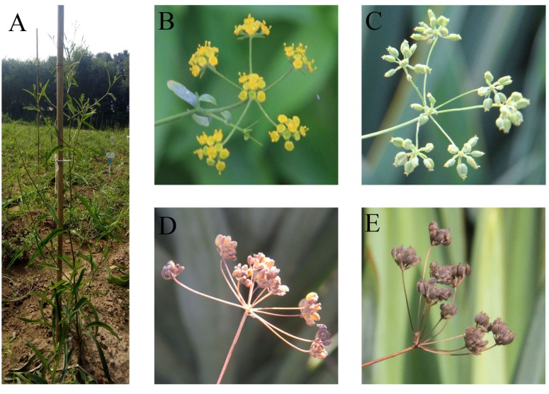

Fig. S4 Description of sampling time based on the flower or seed color. (a) The morphology of the adult Bupleurum chinense DC. plant. (b) FB stage: the blooming inflorescences of B. chinense DC. plant. (c) IG stage: the seeds were immature when the color of seed’s surface was light green. (d) R stage: the seeds were ripe when the color of seed’s surface changed from light green to light red. (e) H stage: the seeds would drop when the color of seed’s surface changed from light red to brown.

